Screen shots for Quality assignment

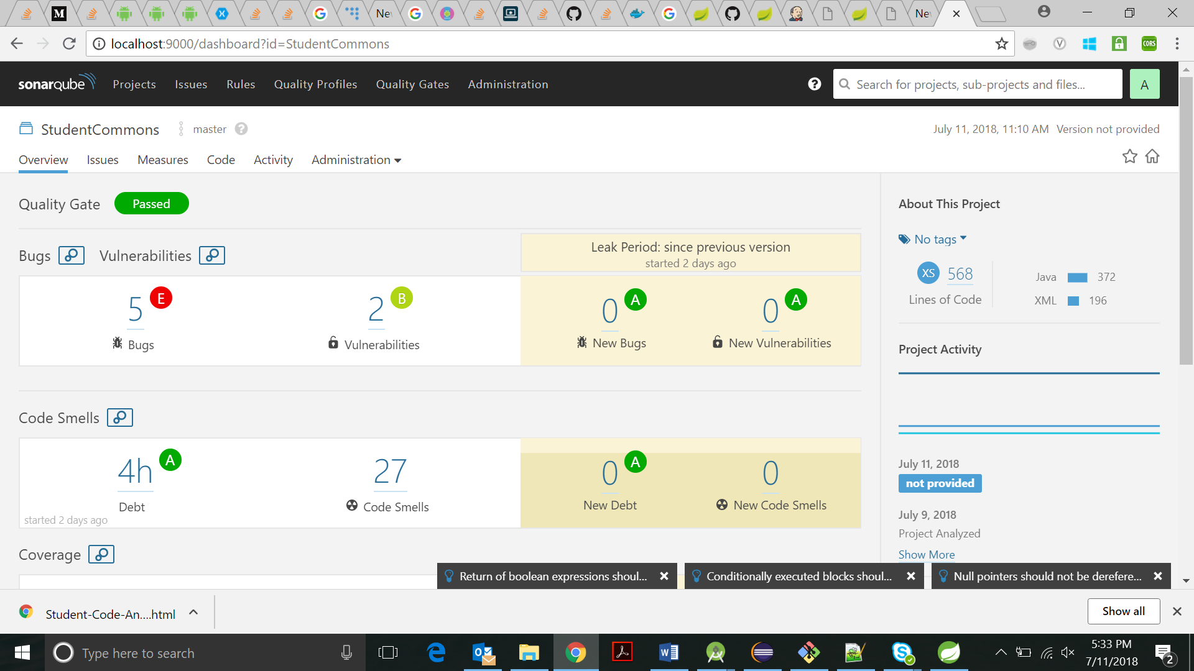

SonarQube result after first build.

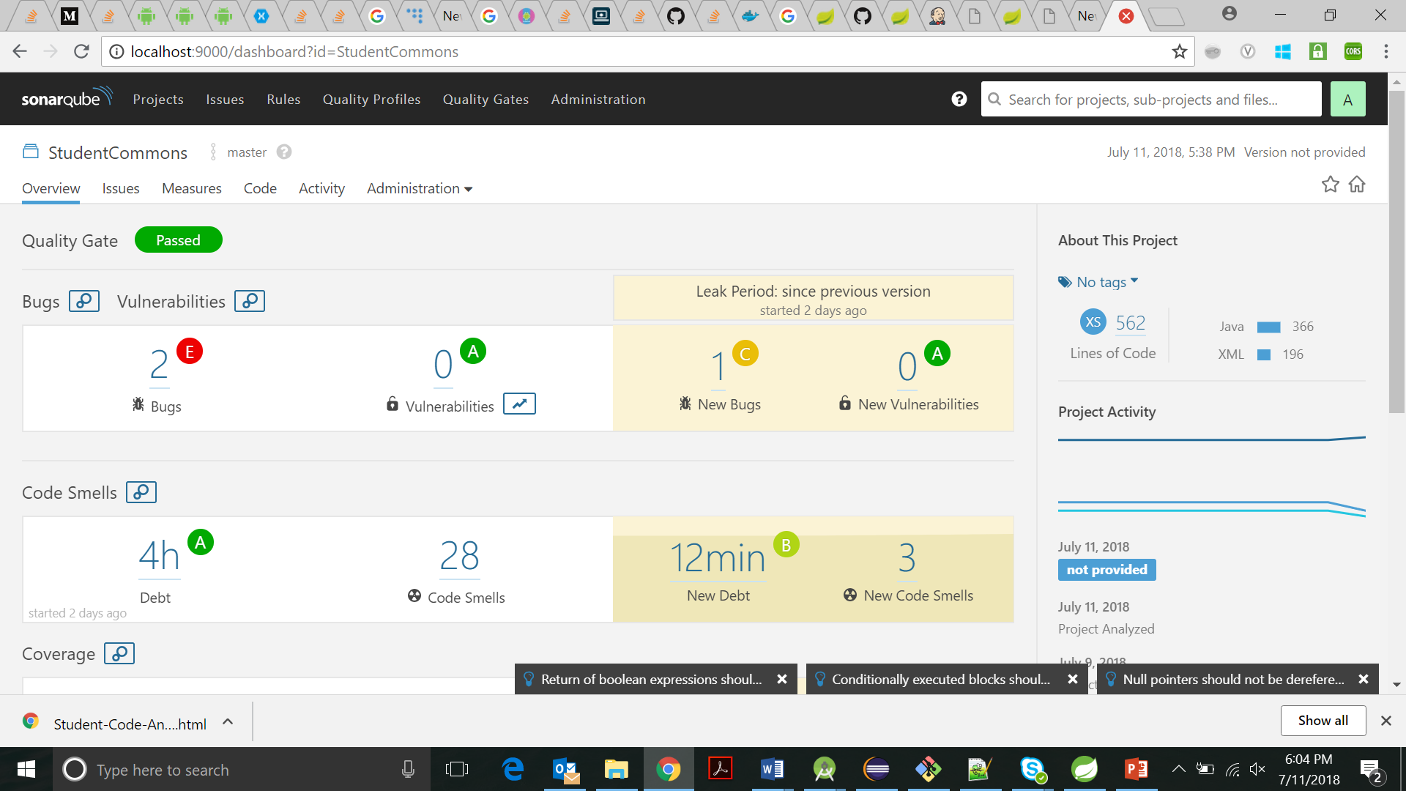

SonarQube result after initial correction of bugs.

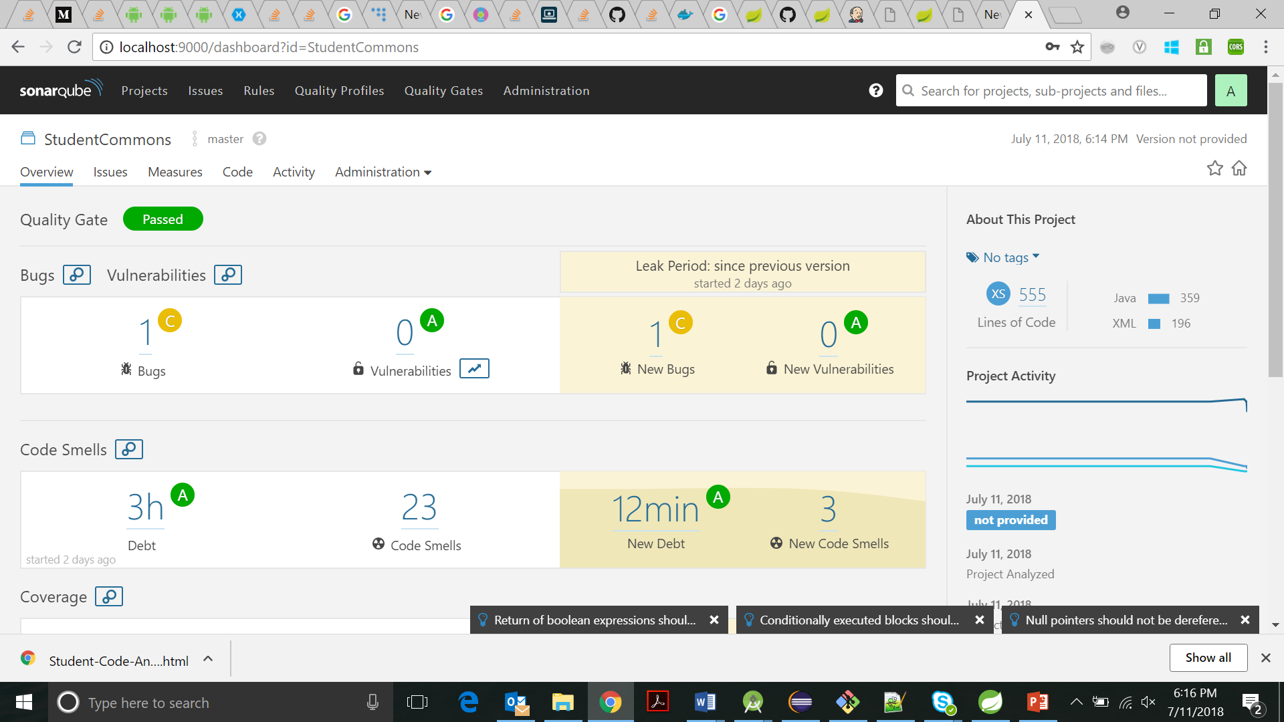

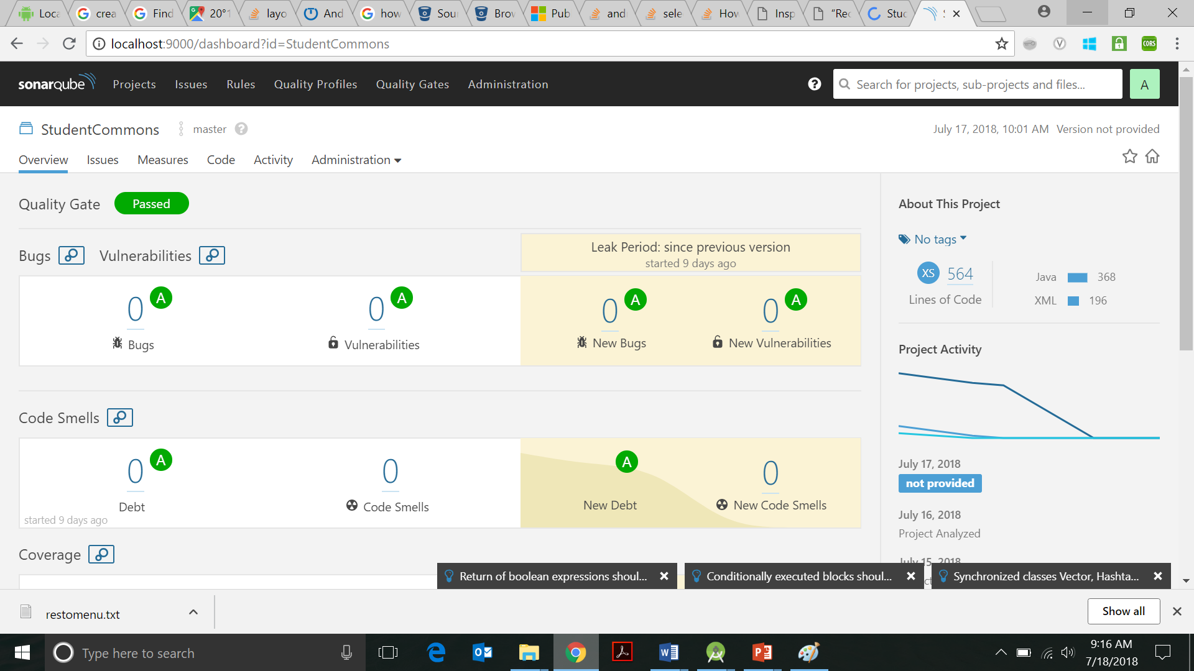

SonarQube result after correcting all bugs and code smells.

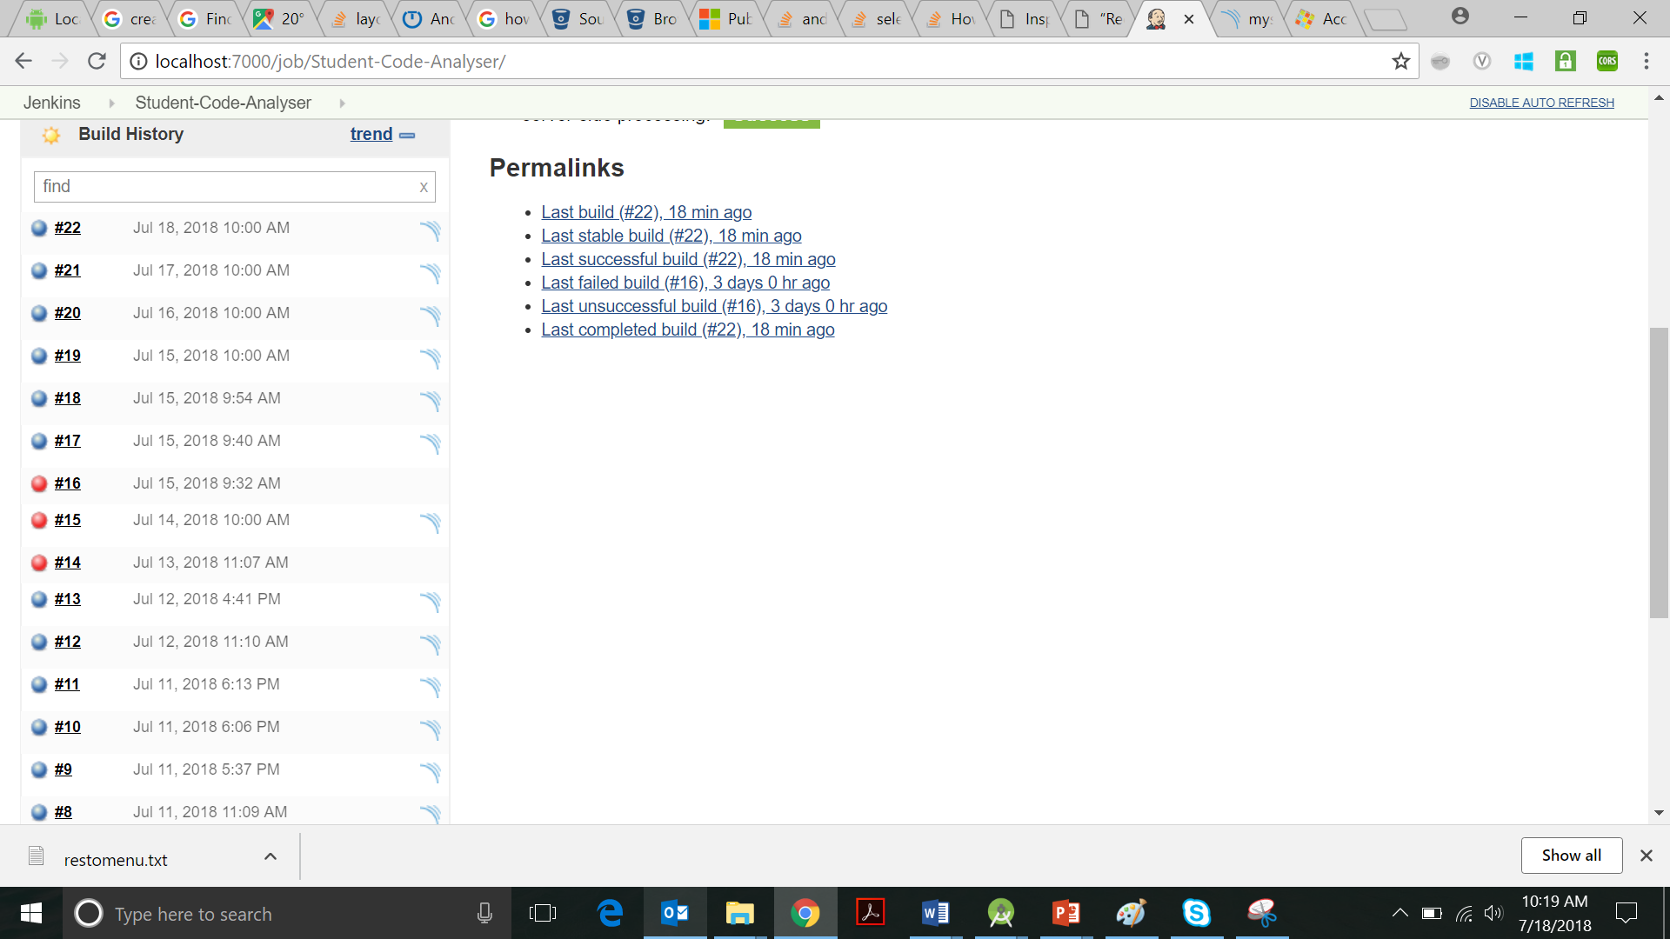

Student-code-Analyser Build history

(There were some build failures since SonarQube was switched off due restarting of laptops during updates and at other times the internet connection was very slow, thus could not connect to git)